**TASK 2**

Use command-line tools to perform the following tasks in Linux:

Create a directory structure /tmp/myfiles and navigate into it.

Create three text files, write sample content in them, and list the files in the directory.

Change the permissions of one file to read-only for the group.  
  
  
**STEPS ----**

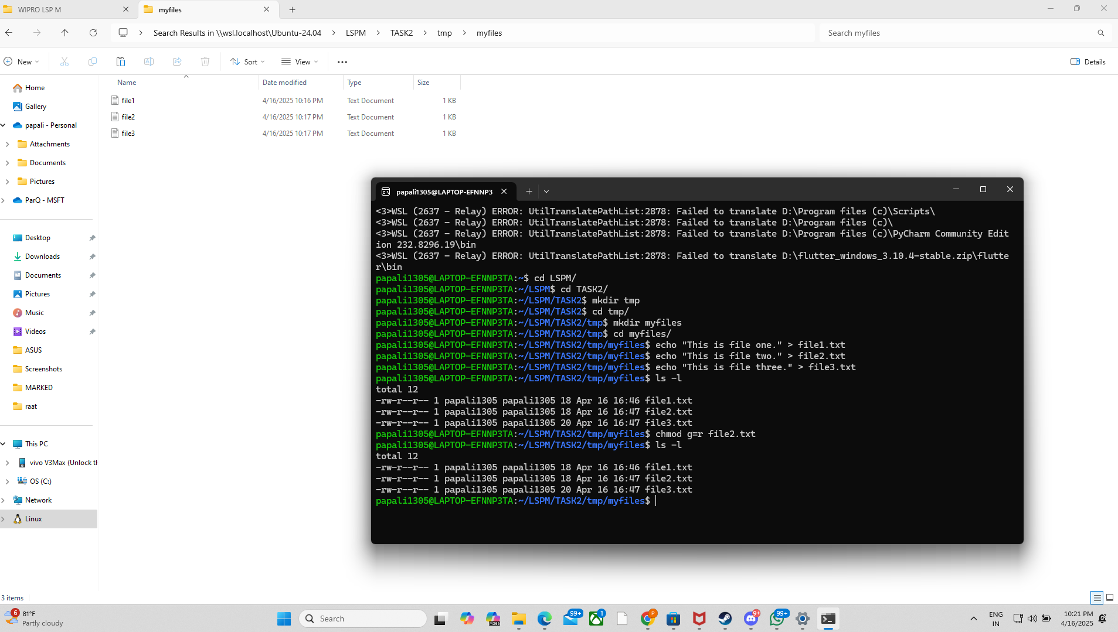

**FILES----**

